Media Kit
Betty J. Slade
Author, Columnist, Artist
970-264-2824

Hello! In my Media-Kit, you’ll find information for your audience, podcasts and Radio interviews—photos, bios, and social media links.

I was asked by an interviewer what I had to bring to her audience? I believe I have an understanding of being a Light in a creative way to an opposing dark place. I have included a brief statement—why I’m passionate for the Christian creative writers and artists and how I can help them reach their potential.

I’d like to be a guest on your radio show or podcast.

Head Shots

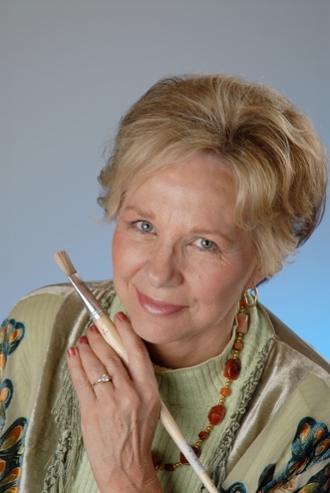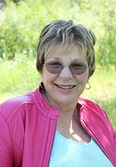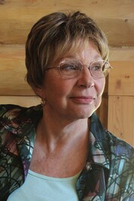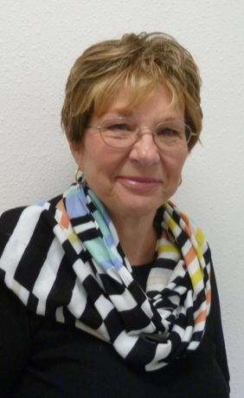

Writer’s Short BIO
Betty J. Slade is an author, columnist, and artist. She has written over six hundred articles for the Pagosa Springs SUN Newspaper in her weekly column, The Artist’s Lane. She also created the Matter of Faith Column. Betty’s early novels include Spirit of the Red Candle— Journal of Mary Magdalene, and the Heart Bender Trilogy. Her Bible Study books are The King’s Choice—Song of Solomon and Hearing the Whispering Dove Workbook, and Cameo—A Study of Ruth. Betty is published in three current anthologies: Twenty-Three Journeys to Christ, Looking at Life, and A Book of Remembrance.

Soon to be released! Taming Wild Hearts, Book one in the Disappointment Valley Series. A novel about a Colorado country family, a five-thousand-acre ranch in the heart of the Rocky Mountains and a rare mustang. A western drama, romance, and mystery.

Social Media & Website Links
Learn more about Betty and books she has written — http://www.bettyjslade.com
She enjoys hearing from readers — bettyslade.author@gmail.com
Facebook: https://www.facebook.com/bettyjslade
Instagram: https://www.instagram.com/bettyjslade/
Pinterest: https://www.pinterest.com/bettyslade
LinkedIn: https://www.linkedin.com/in/betty-slade-243a4933/
Alignable: https://www.alignable.com/pagosa-springs-co/betty-j-slade

Professional Affiliations: Writers Groups — Betty J. Slade
American Christian Fiction Writers (ACFW) - https://www.acfw.com/
Wolf Creek Christian Writers Network (WCCWN) –
http://www.wolfcreekwriters.com/betty-slade

Get to know me.

Hello! I’m Betty J. Slade. I’m excited to share my vision with your audience. After years of struggling to find my place and voice as a Christian artist in the creative world, it’s clear to me, we experience the same feelings. Where do I belong?

The world tells us to get a real job. Show us the money. But my heart tells me to honor the gift that God has so graciously put in me. There is a battle in the creative heart as we pursue what we feel, experienced in the Spirit, popular or not.

I write about Courageous Women in Perilous Times. Who are they? Women who have been tempered by life and win by their faith. Their faith is firm, their families are strong, and they are not dictated by their surroundings. They have been raised above the mediocre and have become an influencer of light in a dark world.

Being an artist for 45 years, painting for interior decorators, hanging in business offices, owning a signature gallery, signed and numbered prints carried on the Princess Cruise Line Ships, a television series, displaying my art in elite galleries, all of that, I still bent to the opinions of others and how I measured up. The art world is all about selling and being known.

One day, when I had painted everything on everything, the effort didn’t satisfy what I needed. I pivoted between painting and writing. I turned to writing in 1992, wrote about characters in the Bible, wrote Bible studies. In 2008, for fifteen years, I have written a column for our weekly local newspaper, The Pagosa Springs SUN Newspaper. In the same newspaper, I also spearheaded a column, The Matter of Faith. I lead a team of eighteen writers to write about their faith each week.

When I hear from readers who have expressed how they love reading my column, The Artist’s Lane, and how they have been changed by my words, I found my place. My gift had made room for me and it has been brought full circle. That’s what I needed. I was tired of making noise, I wanted to make a difference.

I live in Pagosa Springs, Colorado with her husband Al. We have four adult children, two sons-in-law, four grandchildren and one great grandchild.

